E-COMMERCE MANAGEMENT SYSTEM

DBMS Project Report

Submitted in partial fulfilment of the

Requirements for the award of the Degree of

BACHELOR OF ENGINEERING

IN

INFORMATION TECHNOLOGY

BY

<VURE SUJITH KUMAR><1602-20-737-049>


Department of Information Technology

Vasavi College of Engineering (Autonomous)

(Affiliated to Osmania University)

Ibrahimbagh, Hyderabad-31

2020

Vasavi College of Engineering (Autonomous)

(Affiliated to Osmania University)

Hyderabad-500 031

Department of Information Technology

DECLARATION BY THE CANDIDATE

I, VURE SUJITH KUMAR, bearing hall ticket numbers, 1602-20-737-049, hereby declare that the project report entitled ”E-COMMERCE MANAGEMENT SYSTEM” Department of Information Technology, Vasavi College of Engineering, Hyderabad, is submitted in partial fulfilment of the requirement for the award of the degree of Bachelor of Engineering in Information Technology

This is a record of bonafide work carried out by me and the results embodied in this project report have not been submitted to any other university or institute for the award of any other degree or diploma.

VURE SUJITH KUMAR,
1602-20-737-049.

(Faculty In-Charge) (Head, Dept. of IT)
INTRODUCTION:

When the idea of shopping pitches in your head the first thing which will rise in our mind is, on which platform we should window-shop. So we came up with an application “E-COMMERCE MANAGEMENT SYSTEM”. In this application you can find all you basic necessities like electronic gadgets, food and clothing.

This project is designed for buying or selling the products. It also helps to register the details of the administrator and customer. The software application is designed in such a manner that it can satisfy the needs of all the house- hold requirements The E-commerce Management System will be a huge marketplace as most of the business are going to implement based on the internet. This system will provide the detailed description of the products to users so that they can compare to the different product and will by the one which is more suitable to them.

PURPOSE:

The main purpose of this application is to make things effortless. The E-commerce management device has many advantages, examine to

standard store as you possibly can examine the value of a product with different e-commerce web sites, and if a person dislikes any product he/she

can return it. While we can employ the modern-day technology to conquer the hassle with the prevailing system.
ENTITY -RELATIONSHIP DIAGRAM
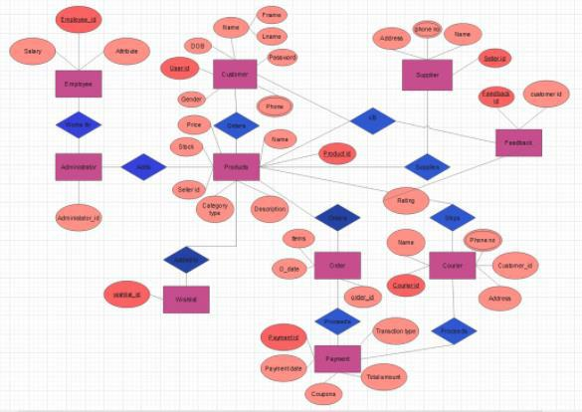
REQUIREMENTS:

1) LIST OF TABLES:

- Product :

The product table has the details of all the products in the stock with the attributes having ID number, name, price, stock, brand, description which will help in accessing them.

Attributes of Product table are:

ID – NUMBER (4,0)

DOB – DATE

FNAME –VARCHAR (20)

LNAME-VARCHAR (20)

PWD-VARCHAR (20)

GENDER- VARCHAR (20)

PH_NO- NUMBER (10, 0)

P_ID- NUMBER (5, 0)

- Customer :

The customer table has the details of all customers logged in the website having their ID number, names, and passwords. They can also access the products that they have and alsoview all other products that are available.

Attributes of Customer table are:

P_ID- NUMBER (5, 0)

P_NAME (20)

STOCK- NUMBER (5, 0)

PRICE - NUMBER (5, 0)

BRAND – VARCHAR (20)

CATEGORY – VARCHAR (20)

DESCRIPTION – VARCHAR (30)
- ARCHITECTURE AND TECHNOLOGY USED:

Java Eclipse, Oracle 11g Database, Java SE version 8, SQL Developer.

SQL developer is an Oracle Database utility, commonly used by users, administrators and programmers.

The interface of SQL Developer is used for creating the database. DDL and DML commands are implemented for operations being executed. The details of students and faculty, their logins, projects are Stored in the form of tables in the database.

Eclipse is an integrated development environment (IDE) used in computer programming. It contains a base workspace and an extensible plug-in system for customizing the environment.

Eclipse is written mostly in java and its primary use is for developing java applications, but it may also be used to develop applications in other programming languages via plug-ins, including Erlang, JavaScript etc.

The front-end application code is written in “Java” using eclipse. The portal for front end application is designed through Eclipse, runs and has the capacity to connect with the database which has data inserted using SQL.

Java AWT (Abstract Window Toolkit) is an API to develop GUI or window

based applications in java.

Java AWT components are platform-dependent i.e., components are displayed according to the view of operating system. AWT is heavyweight i.e., its components are using the resources of OS. The java.awt package provides classes for AWT API such as TextField, Label, TextArea, RadioButton, CheckBox, Choice, List etc.

Java-SQL Connectivity using JDBC

Java Database Connectivity (JDBC) is an application programming interface (API) for the programming language Java, which defines how a client may access a

database. It is a Java-based data access technology used for Java database connectivity. It is part of the Java Standard Edition platform, from Oracle Corporation. It provides methods to query and update data in a database and is oriented towards relational databases.

DATABASE DESIGN:

Setting database connection:
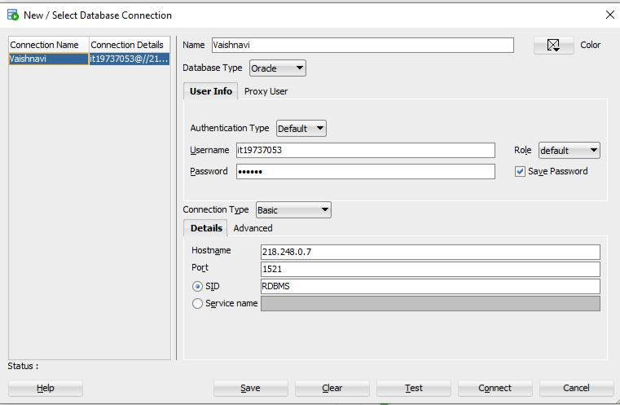

DML operations:

Users table:
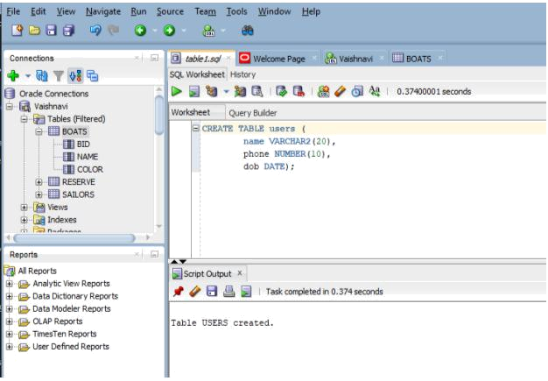

Products table:
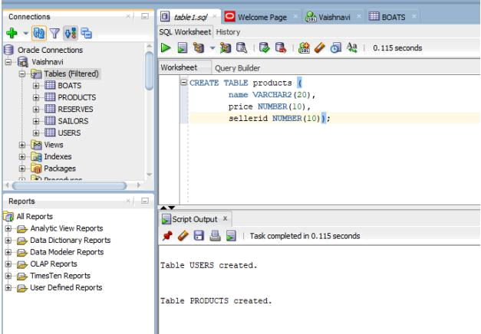

DML operations:
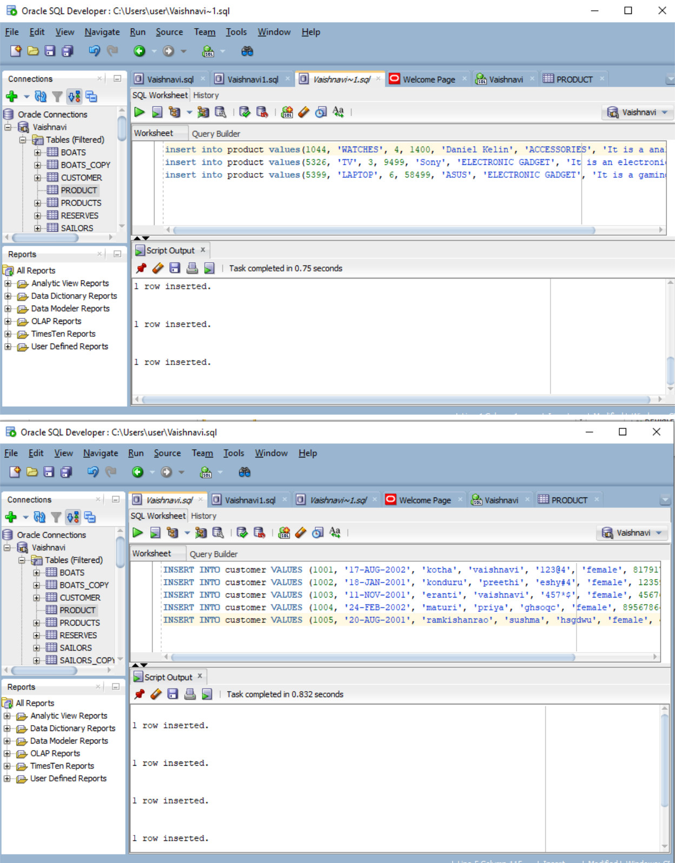
Constraints:
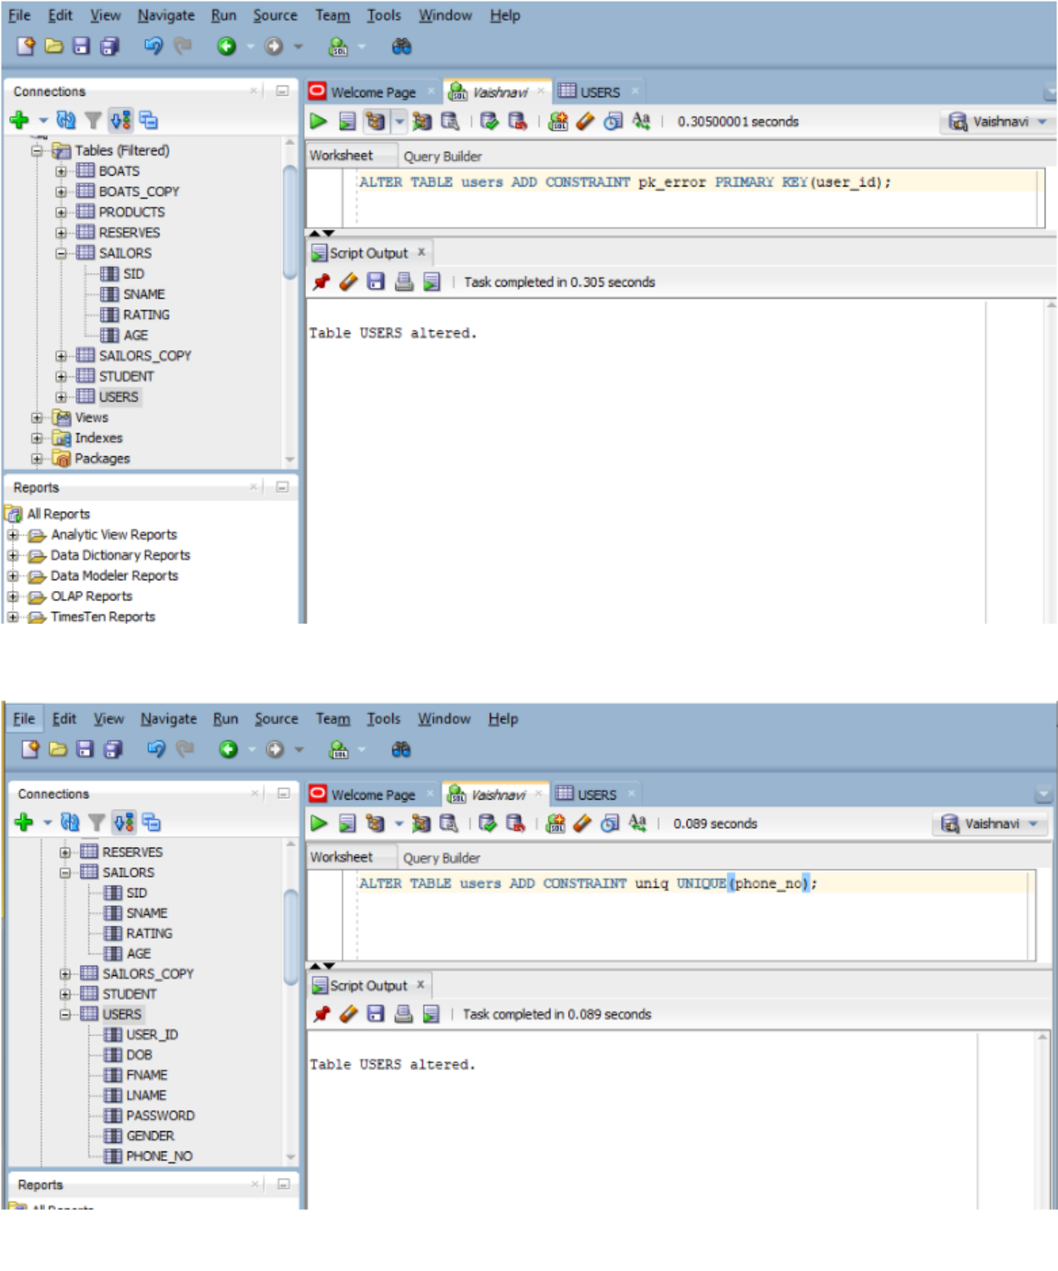

In-built operations:

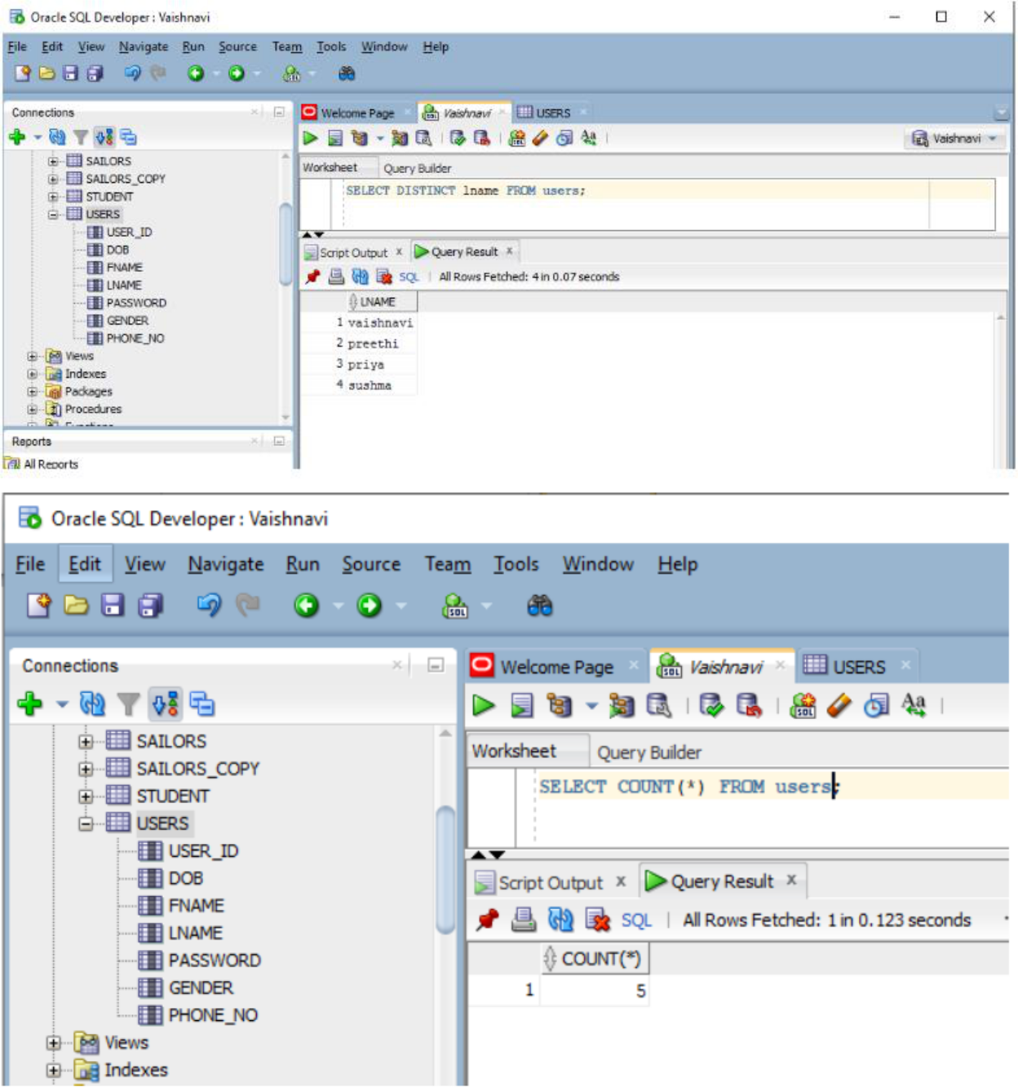
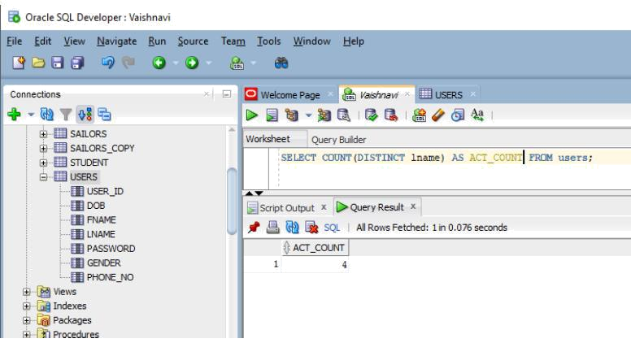

Creating view:
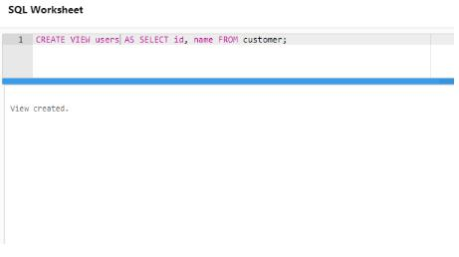
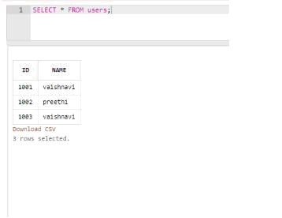

Normalization:

Database Normalization is a technique of organizing the data in the database. Normalization is a systematic approach of decomposing tables to eliminate data redundancy (repetition) and undesirable characteristics like Insertion, Update and Deletion Anomalies. It is a multi-step process that puts data into tabular form, removing duplicated data from the relation tables.

IMPLEMENTATION:

Home.java

Import java.awt.*;

Import java.awt.event.*;

Import javax.swing.*;

public class homePage {

public static void main(String[] args) {

newGui();

}

}
classGui {

JFrame frame = new JFrame("Welcome to e-commerce site");

JLabel heading = new JLabel("E-COMMERCE SITE"); JLabellb = new JLabel("Login as : ");

JButton button1 = new JButton("Customer"); JButton button2 = new JButton("Administator");

Font f1 = new Font(Font.DIALOG_INPUT, Font.BOLD, 20);

Font f2 = new Font(Font.DIALOG_INPUT, Font.PLAIN, 18);

Font f3 = new Font(Font.DIALOG_INPUT, Font.PLAIN, 14);

ColorlightBlue = new Color(164, 206, 237);

Color Blue = new Color(52, 158, 235);

publicGui() {

- setBounds(x, y,width, height); heading.setBounds(200, 20, 200, 20); lb.setBounds(250, 70, 200, 20); button1.setBounds(150, 150, 100, 30); button2.setBounds(300, 150, 150, 30);

heading.setFont(f1);

lb.setFont(f2);

button1.setFont(f3);

button2.setFont(f3);

frame.add(heading);

frame.add(lb);

frame.add(button1);

frame.add(button2);

frame.getContentPane().setBackground(Blue);

button1.setBackground(lightBlue);

button2.setBackground(lightBlue);

button1.addActionListener(new ActionListener() { public void actionPerformed(ActionEventae) {
frame.dispose();

newloginPage();
}

});

button2.addActionListener(new ActionListener() { public void actionPerformed(ActionEventae) {
frame.dispose();

newadmLogin();

}

});

frame.setLayout(null);

frame.setSize(600, 350);

frame.setLocationRelativeTo(null);

frame.setDefaultCloseOperation(JFrame.EXIT_ON_CLOSE);

frame.setVisible(true); }

}

insertProduct.java

importjava.awt.*;

importjava.awt.event.*;

importjava.sql.*;

importjavax.swing.*;

public class insertProduct {

JFrame frame = new JFrame("Inserting products");

JLabel heading = new JLabel("INSERT PRODUCT");

JLabelpId = new JLabel("Enter product id : ");

JLabelpName = new JLabel("Enter product name : ");

JLabel stock = new JLabel("Enter stock : ");

JLabel price = new JLabel("Enter price : ");

JLabel type = new JLabel("Enter the type : ");

JLabel brand = new JLabel("Enter the brand : ");

JLabel description = new JLabel("Enter the description : "); JLabelgo_to = new JLabel("GOTO");

JTextFieldtpId = new JTextField();

JTextFieldtpName = new JTextField();

JTextFieldtStock = new JTextField();

JTextFieldtPrice = new JTextField();

JTextFieldtType = new JTextField();
JTextFieldtBrand = new JTextField();

JTextAreatDescription = new JTextArea();

JTextArearesultText = new JTextArea();

JButton home = new JButton("Home");

JButton insert = new JButton("Insert");

JButton back = new JButton("Back");

Font f1 = new Font(Font.DIALOG_INPUT, Font.BOLD, 20);

Font f3 = new Font(Font.DIALOG_INPUT, Font.PLAIN, 14);

ColorlightBlue = new Color(164, 206, 237);

Color Blue = new Color(52, 158, 235);

Statement stmt;

public void connDb() {

try {

Connection con =

DriverManager.getConnection("jdbc:oracle:thin:@218.248.0.7:1521:rdbms", "it19737053",

"vasavi");

stmt = con.createStatement();

System.out.println("connection successful");

} catch (SQLException e) { System.out.println(e);

}

}

publicinsertProduct() {

connDb();

heading.setBounds(50, 50, 200, 20);

pId.setBounds(50, 100, 200, 30);

pName.setBounds(50, 150, 200, 30);

tpId.setBounds(250, 100, 150, 30);

tpName.setBounds(250, 150, 150, 30);

stock.setBounds(50, 200, 150, 30);

tStock.setBounds(250, 200, 150, 30);

price.setBounds(50, 250, 150, 30);

tPrice.setBounds(250, 250, 150, 30);

brand.setBounds(50, 300, 150, 30);

tBrand.setBounds(250, 300, 150, 30);
type.setBounds(50, 350, 150, 30);

tType.setBounds(250, 350, 150, 30);

description.setBounds(50, 400, 200, 30);

tDescription.setBounds(250, 400, 150, 30);

resultText.setBounds(250, 450, 200, 150);

insert.setBounds(50, 450, 100, 30);

go_to.setBounds(50, 500, 100, 30);

home.setBounds(50, 550, 100, 30);

back.setBounds(50, 600, 100, 30);

heading.setFont(f1);

pId.setFont(f3);

pName.setFont(f3);

tpId.setFont(f3);

tpName.setFont(f3);

stock.setFont(f3);

tStock.setFont(f3);

price.setFont(f3);

;

tPrice.setFont(f3);

brand.setFont(f3);

tBrand.setFont(f3);

type.setFont(f3);

tType.setFont(f3);

description.setFont(f3);

tDescription.setFont(f3);

resultText.setFont(f3);

insert.setFont(f3);

go_to.setFont(f3);

home.setFont(f3);

back.setFont(f3);

frame.getContentPane().setBackground(Blue);

insert.setBackground(lightBlue);

home.setBackground(lightBlue);

back.setBackground(lightBlue);

frame.add(heading);

frame.add(pId);

frame.add(pName);

frame.add(tpId);

frame.add(tpName);

frame.add(stock);
frame.add(price);

frame.add(brand);

frame.add(type);

frame.add(description);

frame.add(tStock);

frame.add(tPrice);

frame.add(tBrand);

frame.add(tType);

frame.add(tDescription);

frame.add(insert);

frame.add(go_to);

frame.add(home);

frame.add(resultText);

frame.add(back);

frame.setLayout(null);

frame.setVisible(true);

frame.setBounds(10, 10, 500, 700);

frame.setLocationRelativeTo(null);

frame.setDefaultCloseOperation(JFrame.EXIT_ON_CLOSE);

frame.setResizable(false);

insert.addActionListener(new ActionListener() { public void actionPerformed(ActionEventae) {

try {

String query = "INSERT INTO product VALUES(" + tpId.getText() + ",'" + tpName.getText() + "',"

+ tStock.getText() + "," + tPrice.getText() +

",'" + tBrand.getText() + "','"

+ tType.getText() + "','" +

tDescription.getText() + "' )";

int i = stmt.executeUpdate(query); resultText.append("\nInserted " + i + " rows successfully");

} catch (SQLException e) { System.out.println(e);

}

}

});

home.addActionListener(new ActionListener() {
public void actionPerformed(ActionEventae) {

frame.dispose();

newGui();

}

});

back.addActionListener(new ActionListener() { public void actionPerformed(ActionEventae) {

frame.dispose();

newadmChoice();

}

});

}

}

updateProduct.java

importjavax.swing.*;

importjava.awt.*;

importjava.awt.event.*;

importjava.sql.*;

public class updateProduct {

JFrame frame = new JFrame("Updating products");

JLabel heading = new JLabel("UPDATE PRODUT");

JLabelpId = new JLabel("Enter product id : ");

JLabelpName = new JLabel("Enter product name : ");

JLabel stock = new JLabel("Enter stock : ");

JLabel price = new JLabel("Enter price : ");

JLabel type = new JLabel("Enter the type : "); JLabel brand = new JLabel("Enter the brand : "); JLabel description = new JLabel("Enter description:"); JLabelgo_to = new JLabel("GOTO");

List ids = new List(15);

JTextFieldtpId = new JTextField();

JTextFieldtpName = new JTextField();
JTextFieldtStock = new JTextField();

JTextFieldtPrice = new JTextField();

JTextFieldtType = new JTextField();

JTextFieldtBrand = new JTextField();

JTextAreatDescription = new JTextArea();

JTextArearesultText = new JTextArea();

JButton home = new JButton("Home");

JButton update = new JButton("MODIFY");

JButton back = new JButton("Back");

Font f1 = new Font(Font.DIALOG_INPUT, Font.BOLD, 20);

Font f3 = new Font(Font.DIALOG_INPUT, Font.PLAIN, 14);

ColorlightBlue = new Color(164, 206, 237);

Color Blue = new Color(52, 158, 235);

Statement stmt;

public void connDb() {

try {

Connection con =

DriverManager.getConnection("jdbc:oracle:thin:@218.248.0.7:1521:rdbms", "it19737053",

"vasavi");

stmt = con.createStatement();

System.out.println("connection successful");

} catch (SQLException e) {

System.out.println(e);

}

}

public void loadProducts() {

try {

ResultSetrs;

rs = stmt.executeQuery("SELECT P_ID FROM product"); while (rs.next()) {

ids.add(rs.getString(1));

}
} catch (SQLException e) {

displaySQLErrors(e);

}

}

private void displaySQLErrors(SQLException e) { JOptionPane.showMessageDialog(frame, "Enter valid data types"); resultText.append("\nSQLException: " + e.getMessage() + "\n"); resultText.append("SQLState: " + e.getSQLState() + "\n"); resultText.append("VendorError: " + e.getErrorCode() + "\n");

}

publicupdateProduct() {

connDb();

loadProducts();

ids.setBounds(50, 100, 200, 350);

heading.setBounds(150, 50, 200, 20);

pId.setBounds(300, 100, 200, 30);

pName.setBounds(300, 150, 200, 30);

tpId.setBounds(450, 100, 150, 30);

tpName.setBounds(450, 150, 150, 30);

stock.setBounds(300, 200, 150, 30);

tStock.setBounds(450, 200, 150, 30);

price.setBounds(300, 250, 150, 30);

tPrice.setBounds(450, 250, 150, 30);

brand.setBounds(300, 300, 150, 30);

tBrand.setBounds(450, 300, 150, 30);

type.setBounds(300, 350, 150, 30);

tType.setBounds(450, 350, 150, 30);

description.setBounds(270, 400, 150, 30);

tDescription.setBounds(450, 400, 150, 30);

resultText.setBounds(300, 450, 200, 150);

update.setBounds(50, 470, 100, 30);

go_to.setBounds(50, 500, 100, 30);

home.setBounds(50, 550, 100, 30);

back.setBounds(50, 600, 100, 30);
heading.setFont(f1);

pId.setFont(f3);

pName.setFont(f3);

tpId.setFont(f3);

tpName.setFont(f3);

stock.setFont(f3);

tStock.setFont(f3);

price.setFont(f3);

tPrice.setFont(f3);

brand.setFont(f3);

tBrand.setFont(f3);

type.setFont(f3);

tType.setFont(f3);

description.setFont(f3);

tDescription.setFont(f3);

resultText.setFont(f3);

update.setFont(f3);

go_to.setFont(f3);

home.setFont(f3);

back.setFont(f3);

ids.setFont(f3);

frame.getContentPane().setBackground(Blue);

update.setBackground(lightBlue);

home.setBackground(lightBlue);

back.setBackground(lightBlue);

frame.add(ids);

frame.add(heading);

frame.add(pId);

frame.add(pName);

frame.add(tpId);

frame.add(tpName);

frame.add(stock);

frame.add(price);

frame.add(brand);

frame.add(type);

frame.add(description);

frame.add(tStock);

frame.add(tPrice);
frame.add(tBrand);

frame.add(tType);

frame.add(tDescription);

frame.add(update);

frame.add(go_to);

frame.add(home);

frame.add(resultText);

frame.add(back);

frame.setLayout(null);

frame.setVisible(true);

frame.setBounds(10, 10, 700, 700);

frame.setDefaultCloseOperation(JFrame.EXIT_ON_CLOSE);

frame.setLocationRelativeTo(null);

frame.setResizable(false);

ids.addItemListener(new ItemListener() {

public void itemStateChanged(ItemEventae) {

try {

ResultSetrs;

rs = stmt.executeQuery("SELECT * FROM product where P_ID ='" + ids.getSelectedItem() + "'");

rs.next();

tpId.setText(rs.getString(1));

tpName.setText(rs.getString(2));

tStock.setText(rs.getString(3));

tPrice.setText(rs.getString(4));

tType.setText(rs.getString(6));

tBrand.setText(rs.getString(5));

tDescription.setText(rs.getString(7));

} catch (SQLExceptionselectException) { displaySQLErrors(selectException);

}

}

});

update.addActionListener(new ActionListener() { public void actionPerformed(ActionEventae) {
try {

int i = stmt.executeUpdate("UPDATE product " + "SET P_ID=" + tpId.getText() + ", " + "P_NAME='"

+ tpName.getText() + "', " + "STOCK=" + tStock.getText() + ", " + "PRICE="

+ tPrice.getText() + ", " + "CATEGORY='"

- tType.getText() + "', " + "BRAND='"

  - tBrand.getText() + "', " +

"DESCRIPTION ='" + tDescription.getText() + "' WHERE p_id = "

  - ids.getSelectedItem());

resultText.append("\nUpdated " + i + " rows successfully");

ids.removeAll();

loadProducts();

} catch (SQLExceptioninsertException) { displaySQLErrors(insertException);

}

}

});

home.addActionListener(new ActionListener() { public void actionPerformed(ActionEventae) {
frame.dispose();

newGui();

}

});

back.addActionListener(new ActionListener() { public void actionPerformed(ActionEventae) {
frame.dispose();

newadmChoice();

}

});

}

}
deleteProduct.java

importjavax.swing.*;

importjava.awt.*;

importjava.awt.event.*;

importjava.sql.*;

public class deleteProduct {

JFrame frame = new JFrame("Updating products");

JLabel heading = new JLabel("DELETE PRODUCT");

JLabelpId = new JLabel("Enter product id : ");

JLabelpName = new JLabel("Enter product name : ");

JLabel stock = new JLabel("Enter stock : ");

JLabel price = new JLabel("Enter price : ");

JLabel type = new JLabel("Enter the type : ");

JLabel brand = new JLabel("Enter the brand : ");

JLabel description = new JLabel("Enter the description:"); JLabelgo_to = new JLabel("GOTO");

List ids = new List(15);

JTextFieldtpId = new JTextField();

JTextFieldtpName = new JTextField();

JTextFieldtStock = new JTextField();

JTextFieldtPrice = new JTextField();

JTextFieldtType = new JTextField();

JTextFieldtBrand = new JTextField();

JTextAreatDescription = new JTextArea();

JTextArearesultText = new JTextArea();

JButton home = new JButton("Home");

JButton delete = new JButton("DELETE");

JButton back = new JButton("Back");

Font f1 = new Font(Font.DIALOG_INPUT, Font.BOLD, 20); Font f3 = new Font(Font.DIALOG_INPUT, Font.PLAIN, 14);

ColorlightBlue = new Color(164, 206, 237);
Color Blue = new Color(52, 158, 235);

Statement stmt;

public void connDb() {

try {

Connection con =

DriverManager.getConnection("jdbc:oracle:thin:@218.248.0.7:1521:rdbms", "it19737053",

"vasavi");

stmt = con.createStatement();

System.out.println("connection successful");

} catch (SQLException e) {

System.out.println(e);

}

}

public void loadProducts() {

try {

ResultSetrs;

rs = stmt.executeQuery("SELECT P_ID FROM product"); while (rs.next()) {

ids.add(rs.getString(1));

}

} catch (SQLException e) { displaySQLErrors(e);

}

}

private void displaySQLErrors(SQLException e) { JOptionPane.showMessageDialog(frame, "Enter valid data types"); resultText.append("\nSQLException: " + e.getMessage() + "\n"); resultText.append("SQLState: " + e.getSQLState() + "\n"); resultText.append("VendorError: " + e.getErrorCode() + "\n");

}

publicdeleteProduct() {

connDb();
loadProducts();

ids.setBounds(50, 100, 200, 350);

heading.setBounds(150, 50, 200, 20);

pId.setBounds(300, 100, 200, 30);

pName.setBounds(300, 150, 200, 30);

tpId.setBounds(450, 100, 150, 30);

tpName.setBounds(450, 150, 150, 30);

stock.setBounds(300, 200, 150, 30);

tStock.setBounds(450, 200, 150, 30);

price.setBounds(300, 250, 150, 30);

tPrice.setBounds(450, 250, 150, 30);

brand.setBounds(300, 300, 150, 30);

tBrand.setBounds(450, 300, 150, 30);

type.setBounds(300, 350, 150, 30);

tType.setBounds(450, 350, 150, 30);

description.setBounds(270, 400, 200, 30);

tDescription.setBounds(450, 400, 150, 30);

resultText.setBounds(300, 450, 300, 150);

delete.setBounds(50, 470, 100, 30);

go_to.setBounds(50, 500, 100, 30);

home.setBounds(50, 550, 100, 30);

back.setBounds(50, 600, 100, 30);

heading.setFont(f1);

pId.setFont(f3);

pName.setFont(f3);

tpId.setFont(f3);

tpName.setFont(f3);

stock.setFont(f3);

tStock.setFont(f3);

price.setFont(f3);

;

tPrice.setFont(f3);

brand.setFont(f3);

tBrand.setFont(f3);

type.setFont(f3);

tType.setFont(f3);

description.setFont(f3);
tDescription.setFont(f3);

resultText.setFont(f3);

delete.setFont(f3);

go_to.setFont(f3);

home.setFont(f3);

back.setFont(f3);

ids.setFont(f3);

frame.getContentPane().setBackground(Blue);

delete.setBackground(lightBlue);

home.setBackground(lightBlue);

back.setBackground(lightBlue);

frame.add(ids);

frame.add(heading);

frame.add(pId);

frame.add(pName);

frame.add(tpId);

frame.add(tpName);

frame.add(stock);

frame.add(price);

frame.add(brand);

frame.add(type);

frame.add(description);

frame.add(tStock);

frame.add(tPrice);

frame.add(tBrand);

frame.add(tType);

frame.add(tDescription);

frame.add(delete);

frame.add(go_to);

frame.add(home);

frame.add(resultText);

frame.add(back);

frame.setLayout(null);

frame.setVisible(true);

frame.setBounds(10, 10, 700, 700);

frame.setLocationRelativeTo(null);

frame.setDefaultCloseOperation(JFrame.EXIT_ON_CLOSE);
frame.setResizable(false);

ids.addItemListener(new ItemListener() {

public void itemStateChanged(ItemEventae) {

try {

ResultSetrs;

rs = stmt.executeQuery("SELECT * FROM product where P_ID ='" + ids.getSelectedItem() + "'");

rs.next();

tpId.setText(rs.getString(1));

tpName.setText(rs.getString(2));

tStock.setText(rs.getString(3));

tPrice.setText(rs.getString(4));

tType.setText(rs.getString(6));

tBrand.setText(rs.getString(5));

tDescription.setText(rs.getString(7));

} catch (SQLExceptionselectException) {

displaySQLErrors(selectException);

}

}

});

delete.addActionListener(new ActionListener() { public void actionPerformed(ActionEventae) {
try {

int i = stmt.executeUpdate("DELETE FROM product WHERE P_ID = " + ids.getSelectedItem());

resultText.append("\nDeleted " + i + " rows successfully");

ids.removeAll();

loadProducts();

} catch (SQLExceptioninsertException) { displaySQLErrors(insertException);

}

}

});

home.addActionListener(new ActionListener() {
public void actionPerformed(ActionEventae) {

frame.dispose();

newGui();

}

});

back.addActionListener(new ActionListener() { public void actionPerformed(ActionEventae) {
frame.dispose();

newadmChoice();

}

});

}

}

GITHUB LINKS AND FOLDER STRUCTURE:

https://github.com/kothavaishnavi2002/E-commerce-management-system

Folder structure:

E-commerce
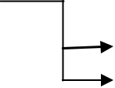

.metadata
e-commerce_database |  | .settings
 |  | bin
 |  | src | 13 .java files
 |  | .classpath
 |  | .project
OUTPUTS AND TESTING:

As the application execution starts it displays home page
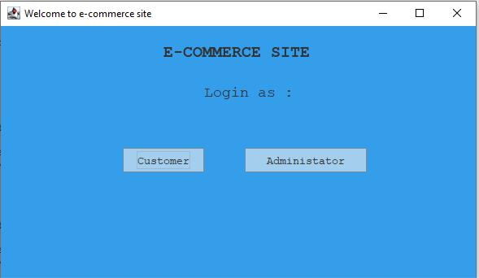

When customer is selected
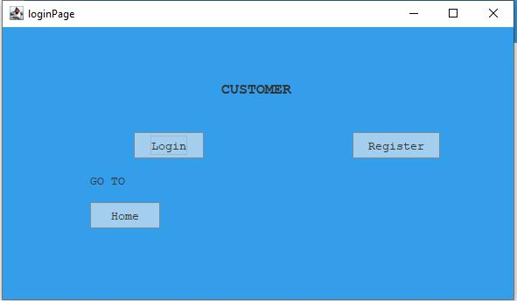
We need to either login or register. On clicking login
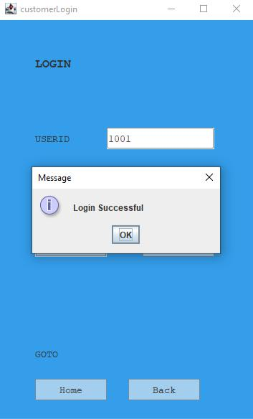

On logging in we will be directed to
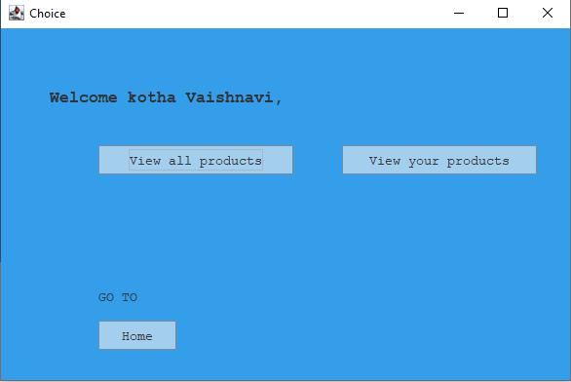

When we select view you products, it shows our products
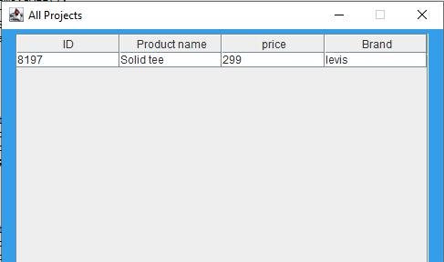

When view all the products is selected, we can either apply filter or view all products
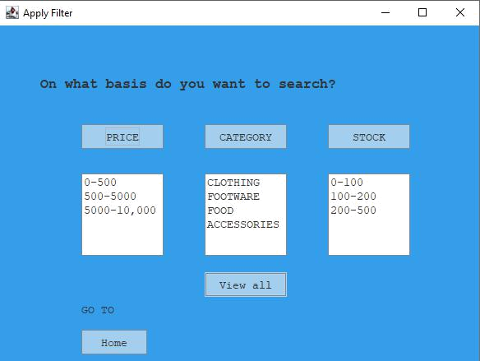

On selecting view all
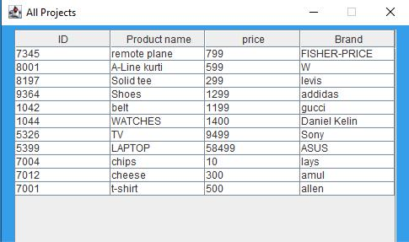
Now the administrator part,
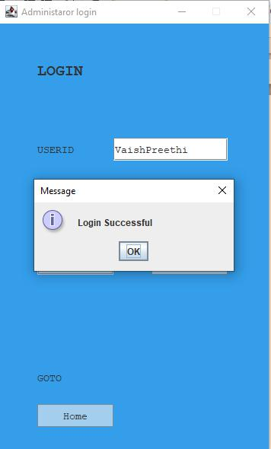

The administrator is asked to choose the operation
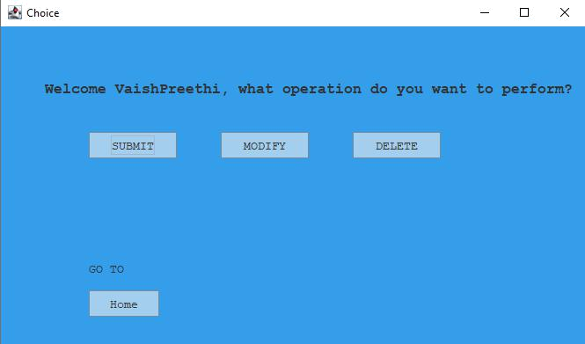

On selecting submit
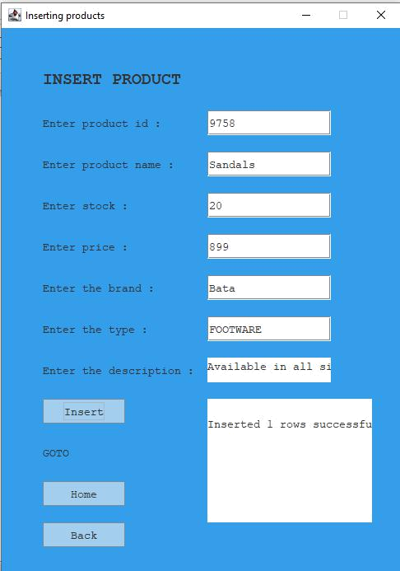
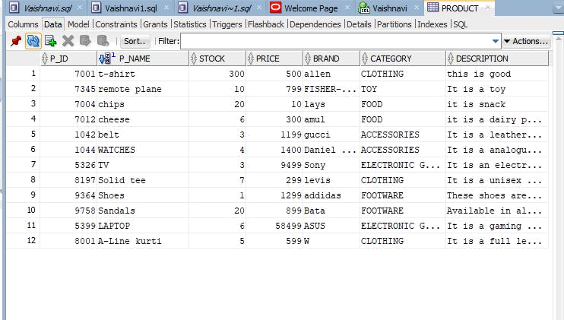

On selecting update
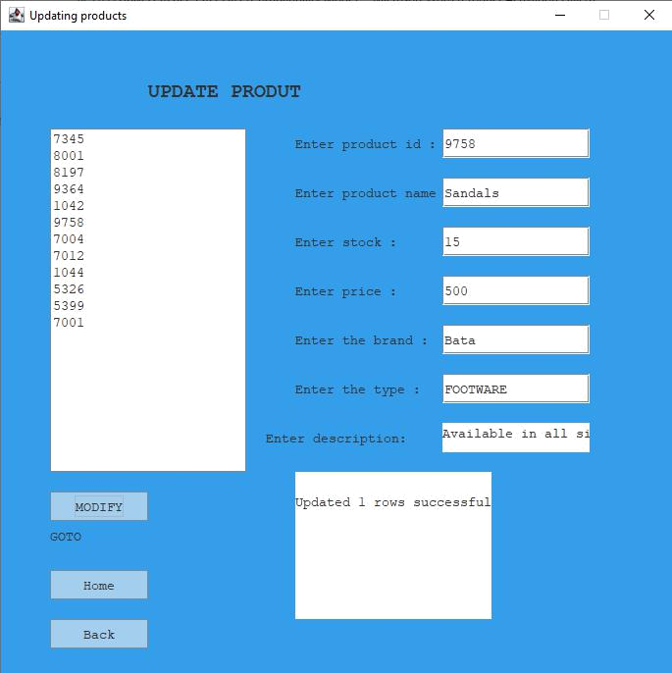
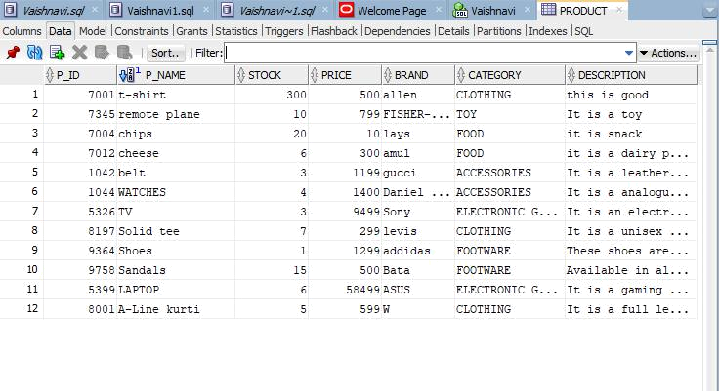

On selecting delete
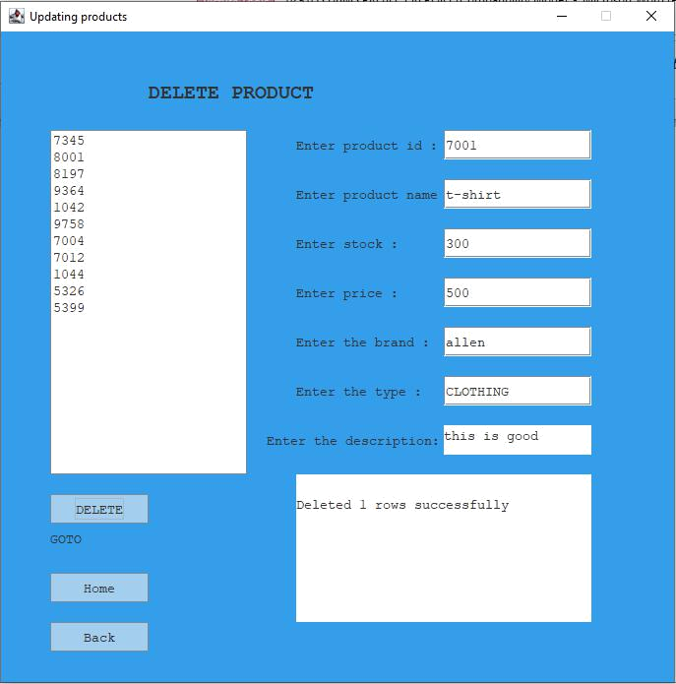
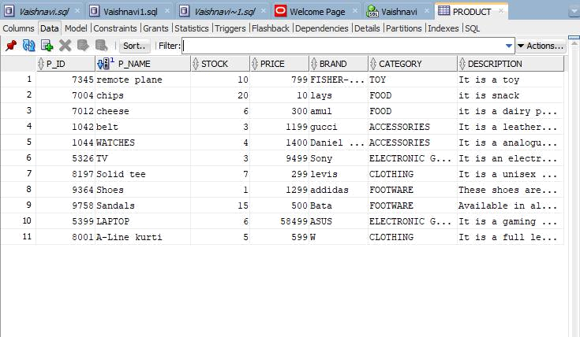
FUTURE WORK:

Not only electronic gadgets, food and clothing, In future we are thinking to add few more facilities to this application like furniture, home appliances etc so that we don’t require any other application for our house hold stuff. We can find everything in one place. And we are also trying various solutions for speeding the delivery time. The e-commerce is available 24 hours of a day and seven days of the week.

REFERANCES:

https://docs.oracle.com/javase/7/docs/api/

https://www.javatpoint.com/java-swing

https://youtu.be/UGG_N9Mlgdw

THANK YOU

